A regression framework incorporating quantitative and negative interaction data improves prediction of quantitative PDZ domain-peptide interaction from primary sequence
Xiaojian Shao^{1,2,5}, Chris S. H. Tan^{2,3,5}, Courtney Voss⁴, Shawn S. C. Li⁴, Naiyang Deng^{1*}, Gary D. Bader^{2,3,*}
1. College of Science, China Agricultural University, Beijing, 100083, China, 2. Banting and Best Department of Medical Research, University of Toronto, Terrence Donnelly Centre for Cellular and Biomolecular Research, Toronto, ON M5S 3E1, Canada, 3. Department of Molecular Genetics, University of Toronto, Toronto ON M5S 3E1, Canada and 4.Department of Biochemistry, University of Western Ontario, London, ON N6A 5B8, Canada
5. These authors contributed equally to this work.
* To whom correspondence should be addressed. E-mail: gary.bader@utoronto.ca (GDB); dengnaiyang@vip.163.com (NYD)

This supplementary file includes:
Supplementary Notes 1, 2, 3, 4, 5
Supplementary Figures 1, 2, 3,4, 5, 6
Supplementary Tables 1, 2, 3, 4, 5, 6, 7, 8
Supplementary Notes
1. Feature encoding
We used the same PDZ domain multiple sequence alignment as published by Chen et al. since we want to compare our method to Chen’s method using the same encoding (e.g. using the same 16 binding sites). This alignment represents the conserved part of the domain containing all conserved secondary structure elements and the canonical binding site. The original PDZ sequences were obtained from the SMART database. We used a 3D protein structure (PDB ID: 2PDZ) including the a1syn-PDZ domain and chose the position (position 22 according to the original alignment of the sequence from the SMART database) as the start of the first secondary structure element (first beta strand) of the PDZ domain as the beginning of the alignment. We choose amino acid (AA) position 139 as the final position of the alignment (resulting in an 118AA long alignment) because almost all the remaining C terminal positions of available domain sequences have >98% gaps per column, that is, only one or two PDZ domains have amino acid in those positions.

2. Position Weight Matrix-based Prediction
A position weight matrix (PWM), or position-specific scoring matrix (PSSM), is a matrix of scores modeling a sequence pattern that can be used to score a protein sequence of fixed length for a match to that pattern. Briefly, the element PWM_{i,j} contains the percentage of amino acid residue j at position i in a set of aligned peptides. Conventionally, the values in a PWM can be computed as log-likelihood values log(PWM_{ij}/P_{i}), where P_{i} is the background probability of amino acid i. A pseudocount of √n, the square root of the total number of the training sequences, was chosen to provide non-zero estimates for all probabilities. Given a new peptide, the log-likelihood ratio can be calculated as the sum of the values of the log-odds matrix corresponding to each amino acid in each position on the peptide sequence.

3. Experimental Methods (In Solution Binding)
Binding constants for the human Scribble PDZ domain were determined using a fluorescence polarization (FP) binding assay. Briefly, the third PDZ domain of human Scribble was expressed as GST fusion proteins using the pETM30 plasmid, purified by GSH affinity chromatography in Purification buffer (PB; 50 mM Bicine pH 8.25, 200 mM NaCl, 0.5 mM EDTA) and eluted with 10 mM GSH (Sigma). Proteins were further purified on an S75 gel filtration column using an AKTA FPLC then concentrated to approximately 60-100 mM using Centricon concentrators (Millipore). Proteins were subsequently serially diluted and 25 ml of each dilution was aliquoted in duplicate to a 384 black fluorescent plate (Corning). Fluorescein labeled human peptides were added to each of these wells at a dilution that provided a fluorescent intensity matching a known peptide. 57 separate peptide-PDZ domain experiments were performed. The fluorescence polarization signal was subsequently measured using an Envision Multi-Label Plate reader (Perkin-Elmer). Binding constants (KD) were calculated using non-linear regression with a one-site binding equation using Graph-Pad Prism software (v3.0).

4. Physicochemical Analysis
We have now analyzed the level at which different physicochemical factors modulate the binding strength. We use the “11-factor” amino acid encoding in (Liu, et al., 2006) to study the physicochemical factors modulating the binding strength of PDZ domain-peptide interactions. These 11 physicochemical factors are: steric parameter, number hydrogen bond donors, hydrophobicity scale, hydrophilicity scale, average accessible surface area, van der Waals parameter R0 (relating to amino acid volume), van der Waals parameter epsilon (relating to number of heavy atoms in a side chain), free energy of solution in water, average side chain orientation angle, polarity and isoelectric point.

To investigate the physicochemical factors that modulate the binding strength of PDZ domain-peptide interactions, we first assessed how well each of the 11 factors can be used individually for quantitative prediction of PDZ domain-peptide interactions using SemiSVR. PDZ domain-peptide interaction data was encoded with each physicochemical factor individually resulting in 11 versions of the same training data. We then constructed a SemiSVR model for each version, and assessed regression performance using leave-one-PDZ-domain-out cross-validation described in the main text. We found that isoelectric point, hydrophilicity scale, polarity, average accessible surface area, van der Waals parameter epsilon and steric parameter are most important in decreasing order, suggesting they are the physicochemical factors that may be modulating the binding strength of PDZ domain-peptide interactions (See Fig. S6). While this is quite interesting, the binding pocket of the PDZ domain is complex (composed of polar, hydrophobic and ionic regions and multiple hydrogen bonds) and we felt it is difficult to relate these properties defined over the entire site to specific structural features without additional structural modeling work. We are currently extending our PDZ interaction methods to consider structural information of the PDZ domain, which we will describe in a future publication.

However, to gain coarse-grained insight on how these physicochemical factors might relate with structural features of PDZ domain-peptide interaction, we analyzed the occurrence of these physicochemical factors among amino acid pairs at 38 interacting positions between PDZ and peptides defined in Chen’s work. We first divided the PDZ domain-peptide interaction data into 3 groups: Non-interacting PDZ domain-peptide pairs (negative), interacting PDZ domain-peptide pairs between 100 uM and 10 uM binding affinity (weak) and interacting PDZ domain-peptide pairs with less than 10 uM affinity (strong). For each pair of amino acids observed at the 38 interacting positions for each PDZ domain-peptide pairs, we convert it into the following 7 values (as they are the physicochemical factors that modulate the binding strength of PDZ domain-peptide interactions, see above analysis) 1) Hydrophilicity_{PDZ}+Hydrophilicity_{Ligangd}, 2) Average ASA_{PDZ}+Average ASA_{Ligand}, 3) Polarity_{PDZ}+Polarity_{Ligand}, 4) Steric parameter_{PDZ}+Steric parameter_{Ligangd}, 5) Hydrogen bond donors_{PDZ}+Hydrogen bond donors_{Ligangd}, 6) van der Waals parameter epsilon_{PDZ}+van der Waals parameter epsilon_{Ligangd} and 7) |isoelectric point_{PDZ} - isoelectric point_{Ligand}| . We then compared the distribution of these 7 values for each interacting positions among strong, weak and negative for PDZ domain-peptide pairs. Based on this analysis, we observed many statistical differences in the distribution of 7 values at multiple interacting positions between weak and negative PDZ domain-peptide pairs and it became challenging to pinpoint the main physico-chemical and structural factors that determine PDZ domain-peptide interactions. However, much fewer interacting positions have observed statistical differences in distribution of these 7 values at the different interacting positions between weak and strong interacting PDZ domain-peptide pairs. Interacting positions with an observed statistical difference, mostly involve positions 0 and -2 of the peptide which is in accordance with existing understanding from structures, which show that these positions interface with the main PDZ domain binding pocket (interacting with binding site amino acids), while positions -1 and -3 point outwards closer to solution, thus are more difficult to relate directly to PDZ domain amino acid positions (Nourry, et al., 2003). We are currently extending our PDZ interaction methods to consider structural information of the PDZ domain, which we will describe in a future publication.

5. Binary Classification Performance on Blind testing data set
We applied the trained SemiSVR to predict the interaction status of a set of protein array negatives determined in (Chen, et al., 2008) that were not used in any previous training set. We have only used high quality fluorescence polarization experiment determined negatives for training, but 16,067 PDZ domain-peptide pairs were measured as array negatives without being subsequently measured by fluorescence polarization, providing an independent, albeit potentially noisy, negative test set. The SemiSVR method predicts that >92% of these interactions are negative (affinity >100μM) and 1173 are positive, indicating that the method performs well at predicting negatives.
Supplemental Figures
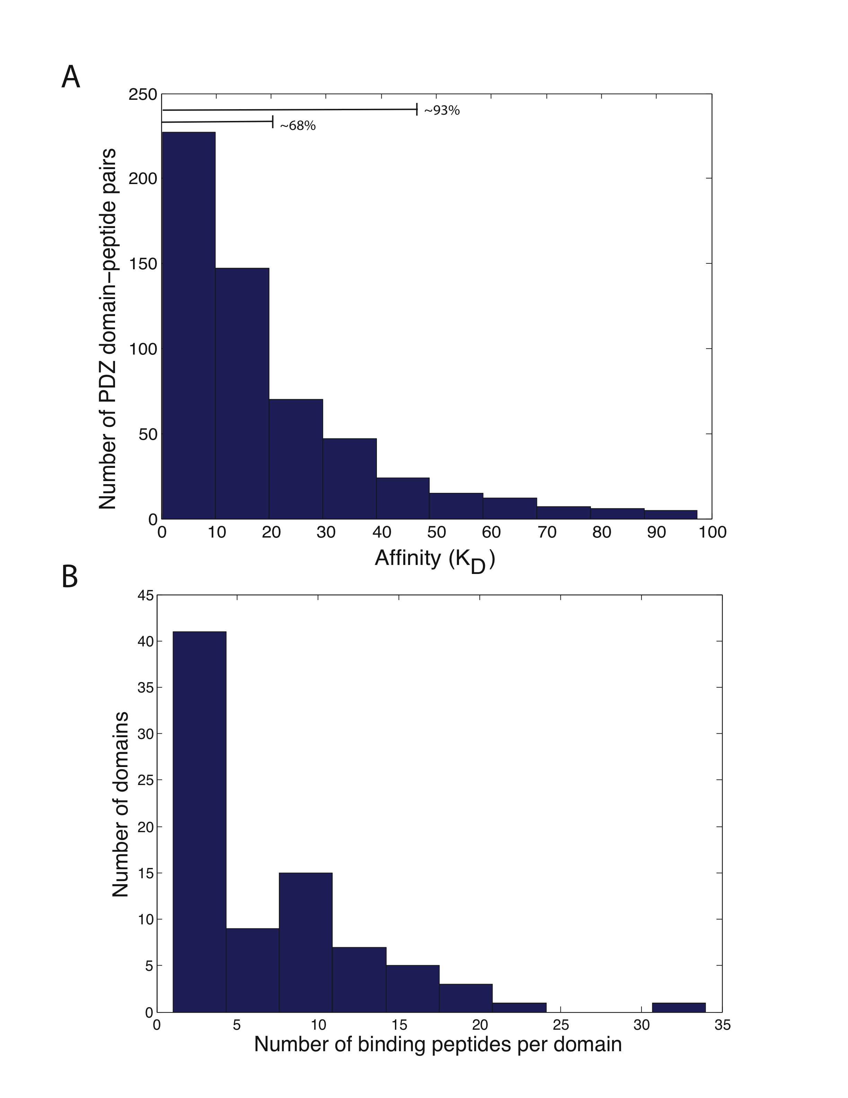
Supplemental Figure 1. (A) Distribution of binding affinities for 560 PDZ domain-peptide interactions. (B) Distribution of the number of binding peptides per PDZ domain.
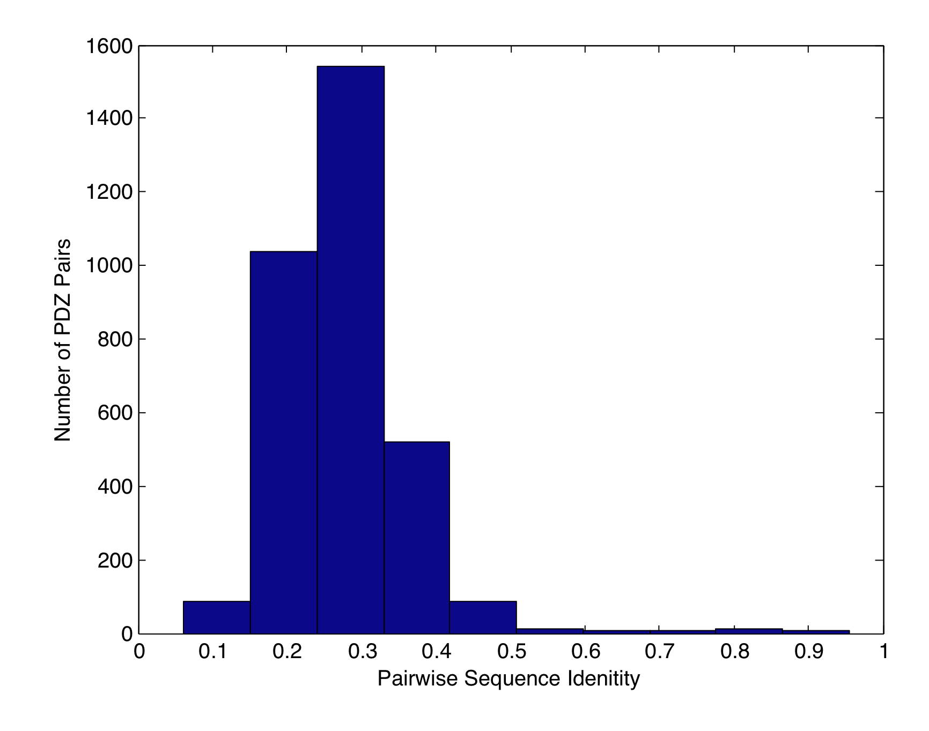
Supplemental Figure 2. Pairwise Sequence Identity Between 82 PDZ Domain Sequences According to 118AAs After Sequence Multiple Alignment. Sequence multiple alignments were obtained from Chen’s paper.

(A) SemiSVR
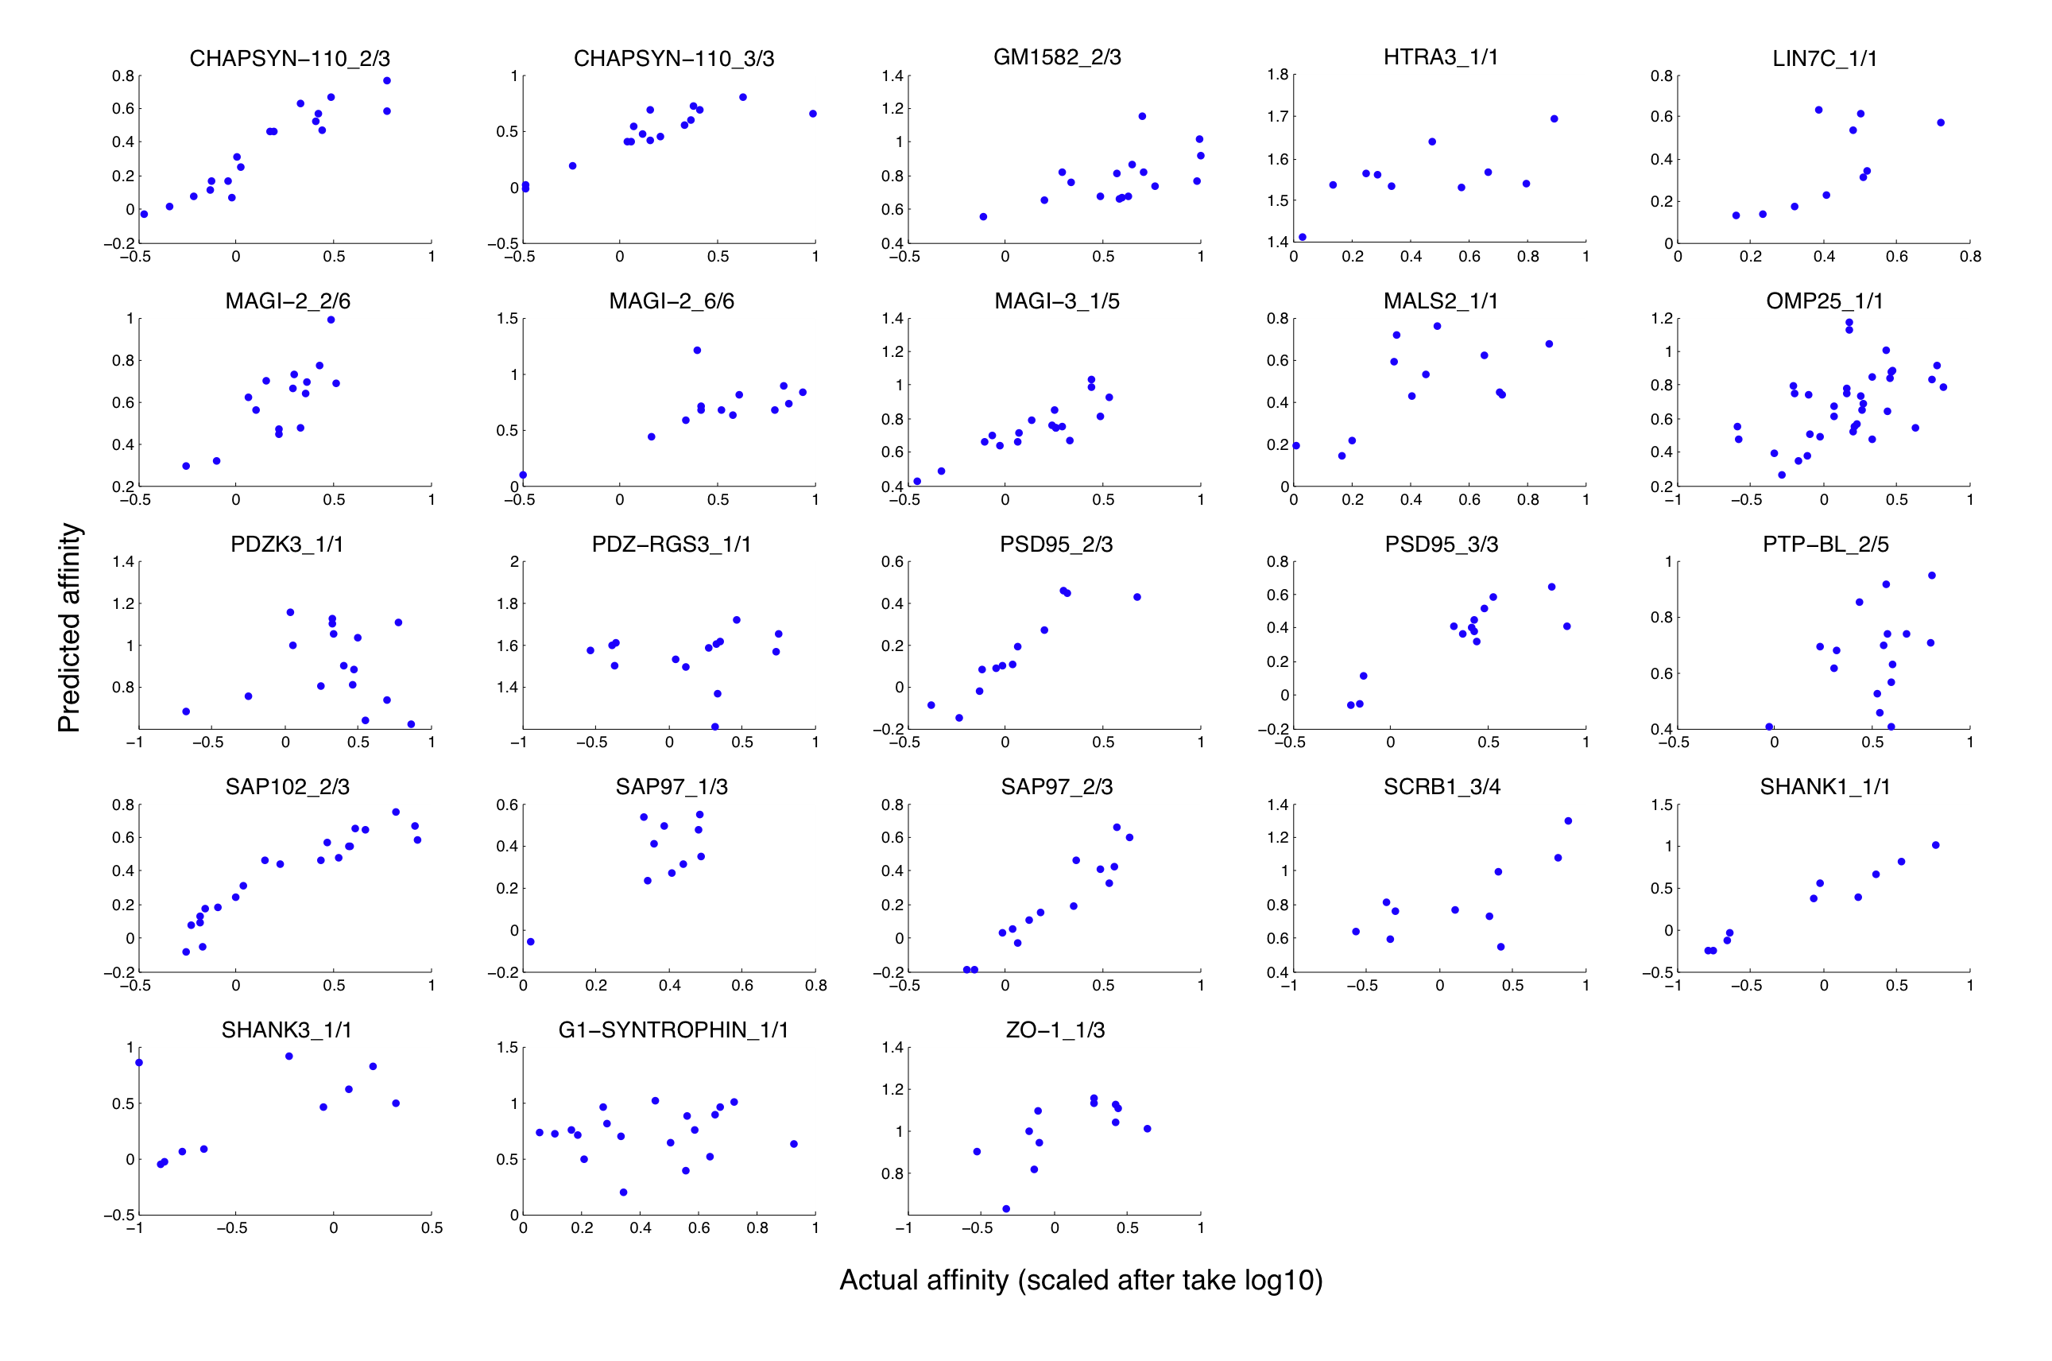
(B) SVR
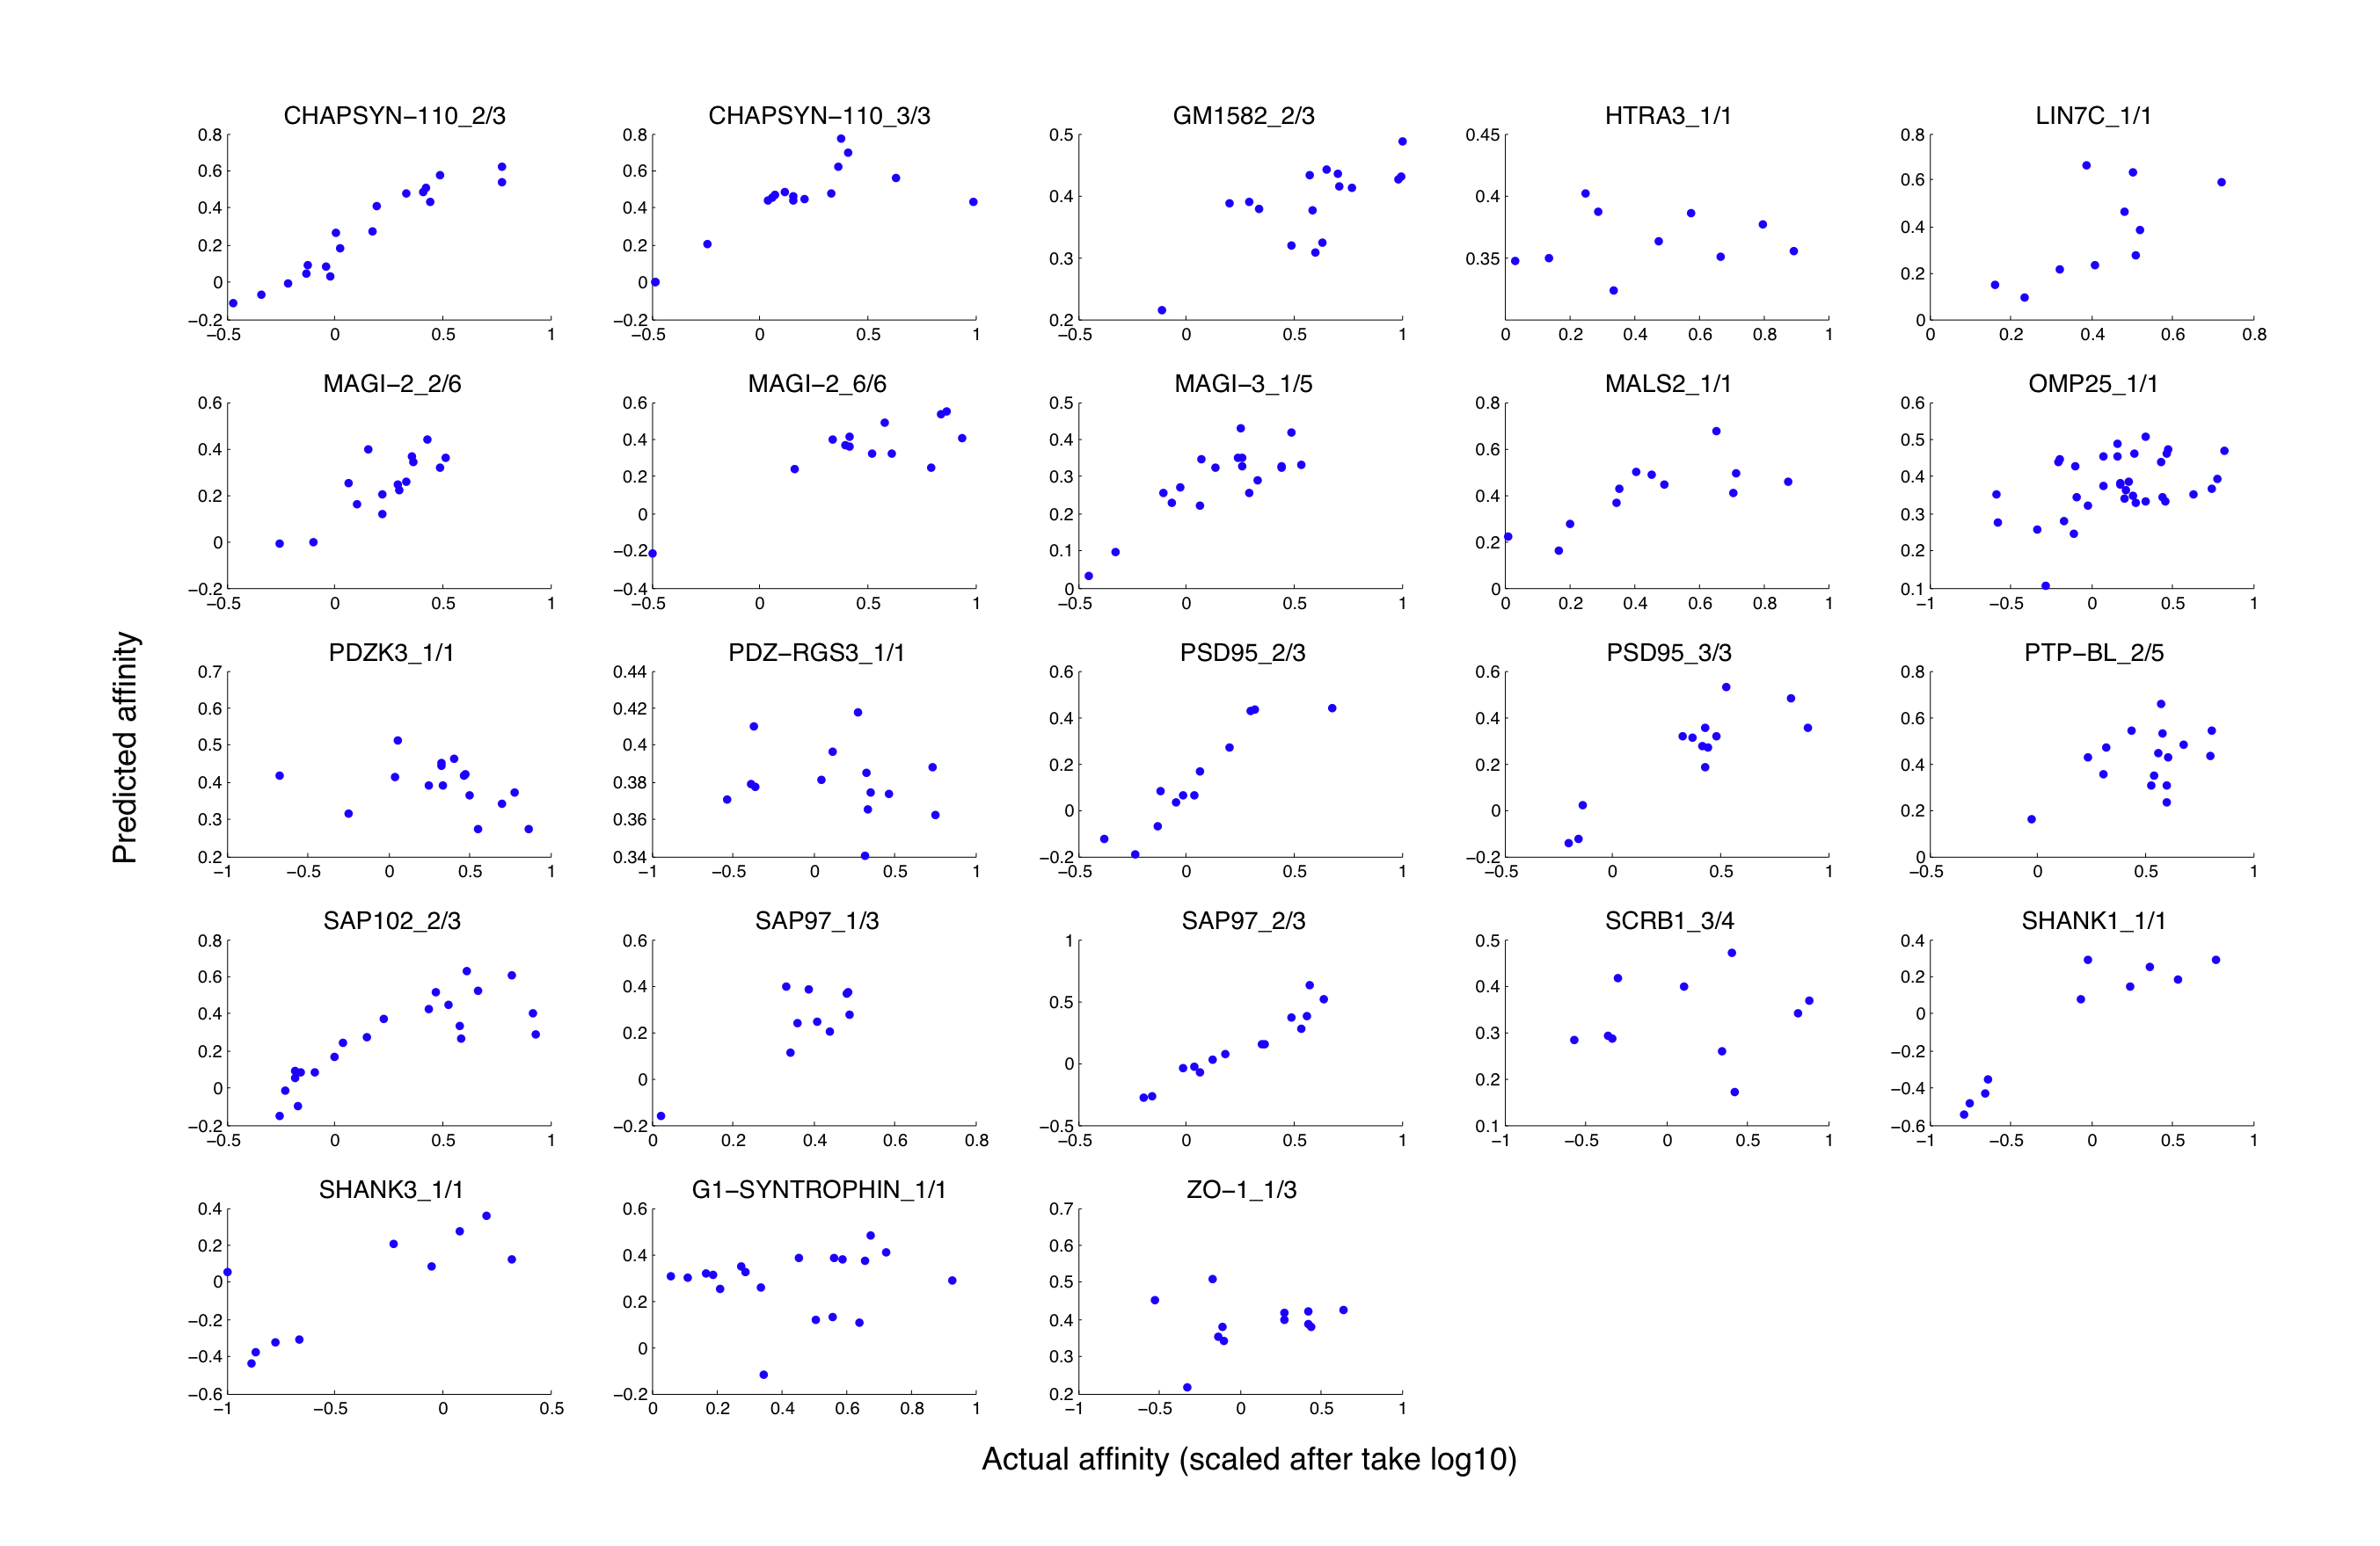
Supplemental Figure 3. Performance of SemiSVR (A) and SVR (B) on predicting relative binding affinity of 23 individual PDZ domains to their peptide ligands. Scaled actual (x-axis) and predicted (y-axis) binding affinities are plotted against each other. Plot titles indicate names of the 23 PDZ domains used. For both methods, polynomial kernels based on wholePDZ_118AAs PDZ domain encoding and 10AAs of peptides were used.
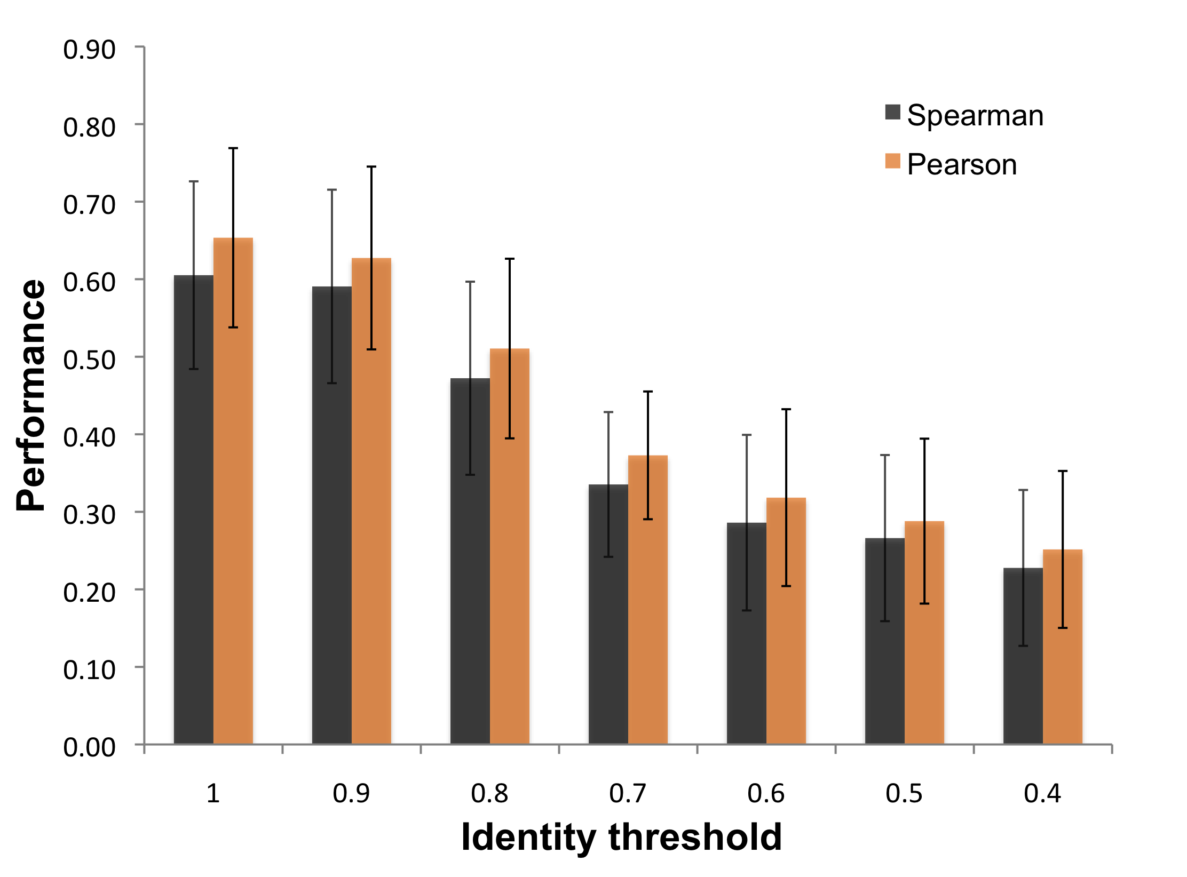
Supplemental Figure 4. Decreasing the Sequence Similarity of the Training and Testing Datasets Decreases Predictor Performance. Identity threshold refers to the sequence identity between testing and training PDZ domains based on the whole 118AA PDZ sequence. All PDZ domains more similar to the test PDZ domain than the given identity threshold are removed from the training set. Error bars represent 95th percentile confidence intervals calculated across all 23 tested PDZ domains.

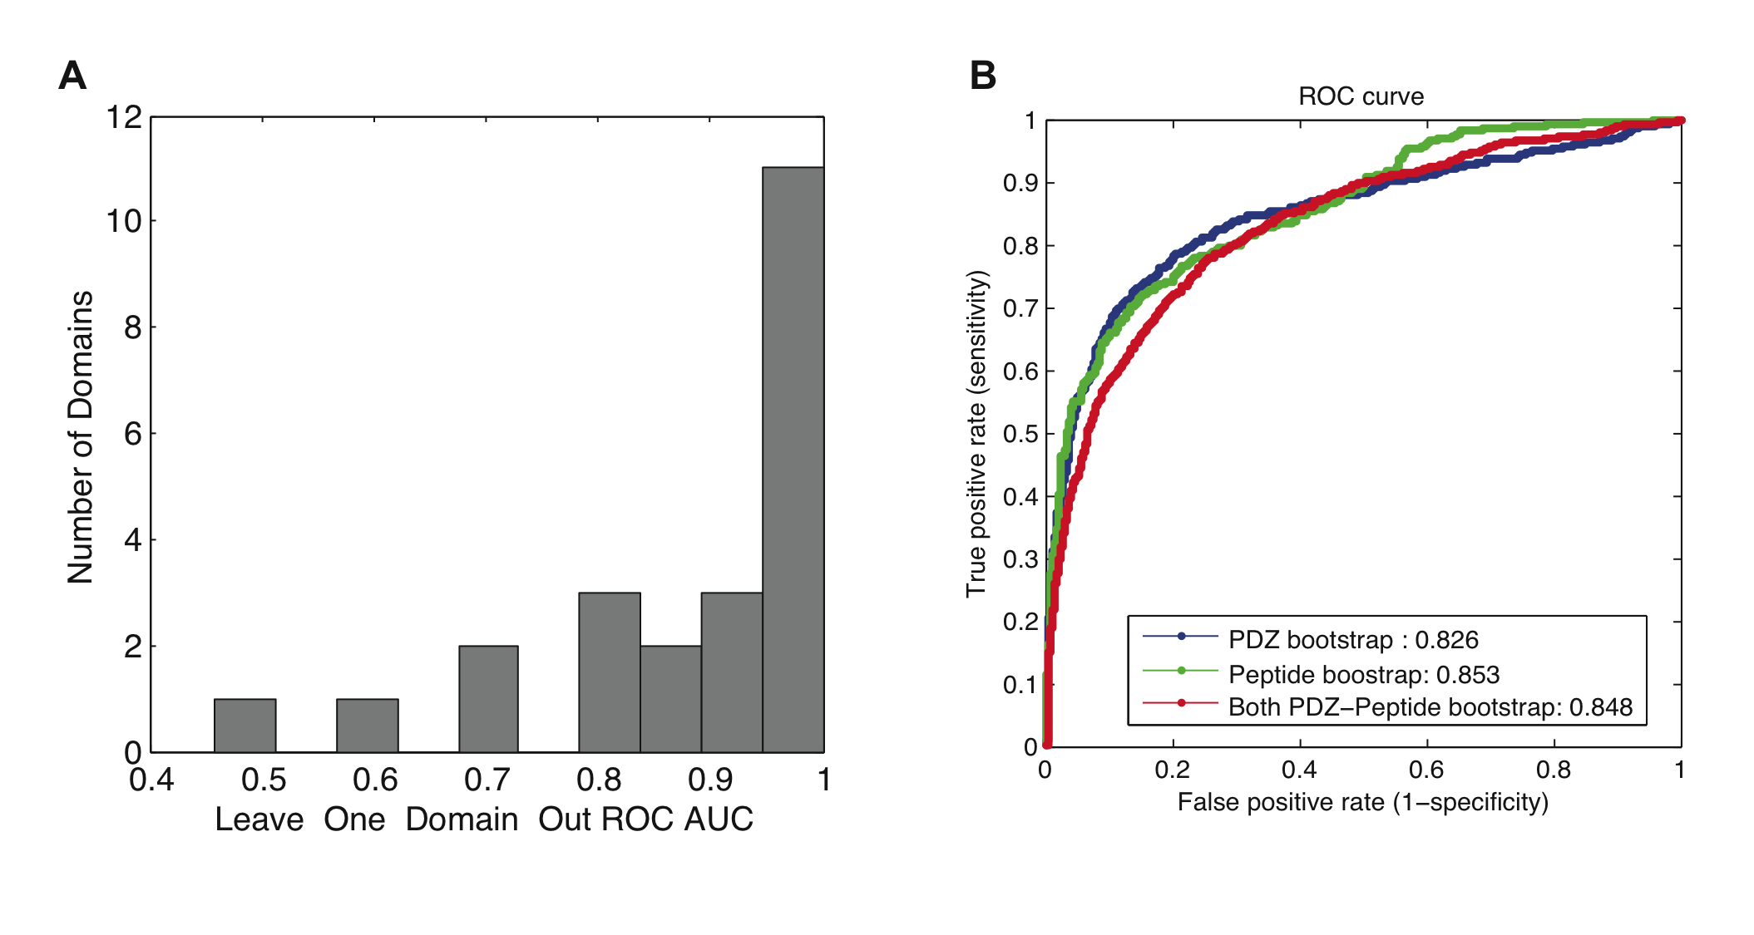
Supplemental Figure 5. SemiSVR Can Accurately Predict Positive or Negative Binding (Binary Classification). (A) Leave-one-PDZ-domain-out cross-validation Area Under the ROC Curve (AUC) for 23 PDZ domains. The average ROC AUC is very high, 0.88. (B) Bootstrap testing on extrapolated PDZ, Peptide, and PDZ-peptide pairs as in Chen et al. (Chen, et al., 2008).
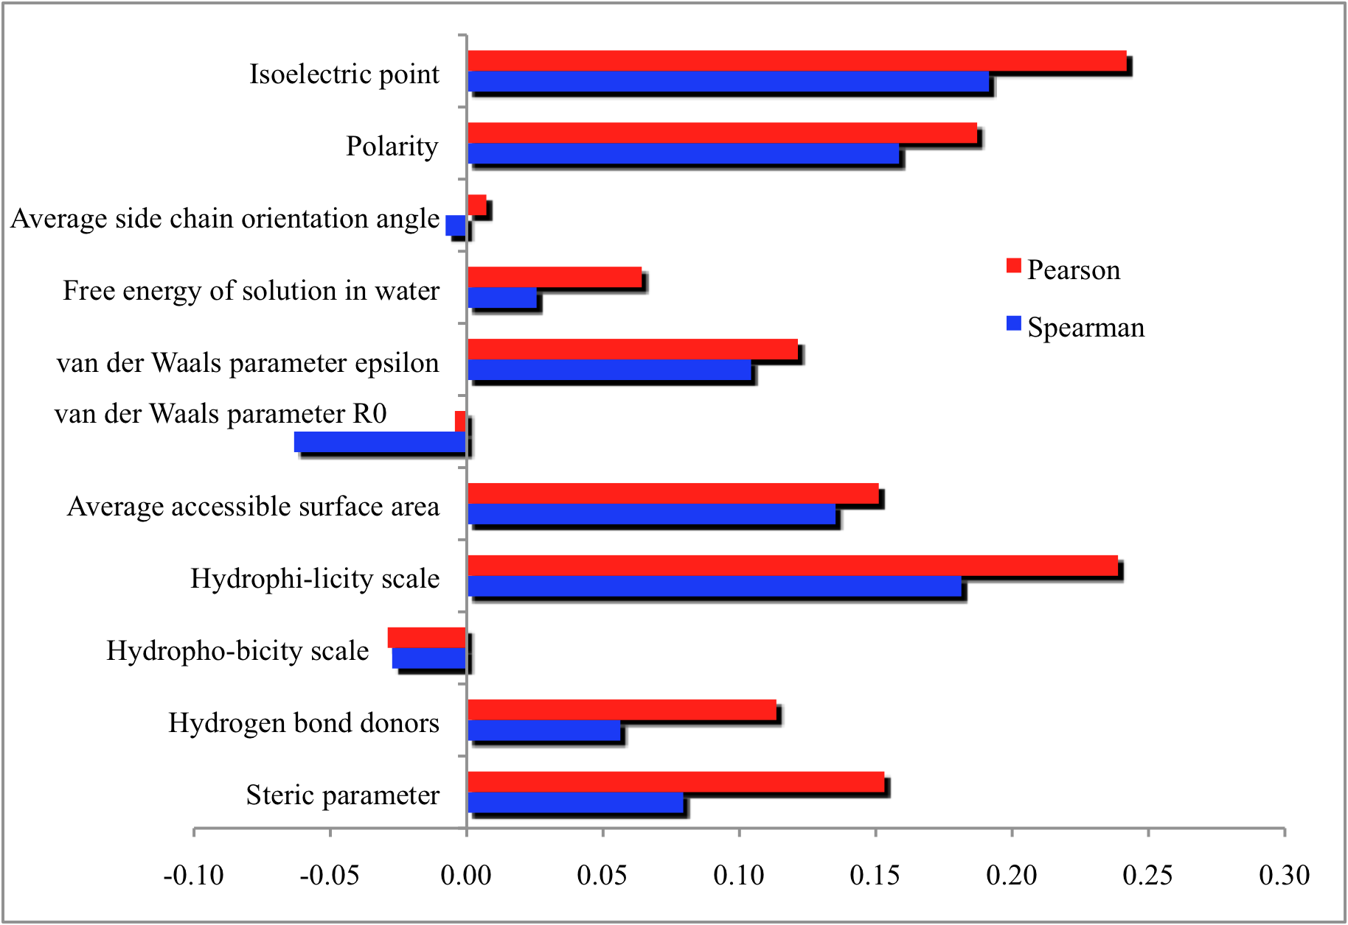
Supplemental Figure 6. Performance of the SemiSVR Based on Each of 11-factor Encoding Individually. The 16 binding sites on PDZ domain, as defined in 38 contact pairs in Chen’s paper, and the 10 AAs of the entire peptide were used for representing PDZ domain-peptide pairs. Spearman and Pearson correlation coefficients were reported as the performance measurement. The isoelectric point, hydrophilicity scale, polarity, average accessible surface area, van der Waals parameter epsilon and steric parameter give decreasing positive result suggesting they are the physicochemical factors that mostly modulating the binding strength of PDZ domain-peptide interactions.
Supplemental Tables
Supplementary Table 1. Quantitative interaction matrix for mouse PDZ domains and training set peptides. The corresponding peptide sequence could be found at the second sheet in Table S1.

Supplementary Table 2. Comparison on different kernels and encodings used by our SemiSVR model. Structure-based 38 pairs, the whole PDZ sequence-118AA and 16 binding sites encoding were used to encode the PDZ domain as well as the Profeat, sparse20 encoding. 11factor, 5factor, zscale, sparse 20 encoding were used for encoding the peptides. The different kernels used are indicated in the table.

Supplemental Table 3. Performance Comparison of SemiSVR with Different Parts of the PDZ Domain for 23 PDZ Domains with Associated Peptides. Each SemiSVR was trained with a polynomial kernel (with p=2) considering both the PDZ domain and the peptide sequence. Bold numbers indicate the best performance. BindingSite-16AA refers to 16 amino acid positions defined by a single PDZ-ligand 3D structure of a1-syntrophin PDZ (a1synPDZ). CoreBindingSite-10AA refers to 10 amino acid positions defined as the intersection of all binding sites in nine available PDZ domain structures co-complexed with peptides(Tonikian, et al., 2008).
Performance Measure | Feature Encoding | SemiSVR Performance
Spearman | WholePDZ-118AA | 0.605
 | BindingSite-16AA | 0.594
 | CoreBindingSite-10AA | 0.594
Pearson | WholePDZ-118AA | 0.653
 | BindingSite-16AA | 0.636
 | CoreBindingSite-10AA | 0.649

Supplemental Table 4. Quantitative interaction Prediction for Human Scribble PDZ domain-peptide pairs.
Name | ID | C-terminus | Kd (μM) (actual) |  | Predicted scaled affinity
 |  |  | PDZ3 | SD | PDZ3
ARD50 | BC024725.1 | SFNYKKETPL | 1.5 | 0.1 | 0.543
MAPK12 | PV3654 | GARVSKETPL | 1.7 | 0.1 | -0.052
ARHGEF16 | NM_014448.2 | MERLRVETDV | 2.1 | 0.1 | 0.615
MCC | NM_002387.1 | SRPHTNETSL | 2.4 | 0.1 | 0.466
ABR | NM_001092.3 | RNTLYFSTDV | 2.9 | 0.1 | 0.899
STK29 | BC024291.1 | KVATSYESSL | 3.2 | 0.2 | 0.705
FAM105B | NM_138348.3 | PVRVCEETSL | 3.4 | 0.2 | 0.446
b-PIX | NP_003890 | NDPAWDETNL | 4.9 | 0.4 | 0.628
APC | NP_000029 | HSGSYLVTSV | 6.7 | 0.4 | 0.521
VANGL2 | NP_065068 | VMRLQSETSV | 8.8 | 0.5 | 0.553
PRKCA | P2227 | FVHPILQSAV | 9.8 | 0.5 | 0.710
AHDC1 | BC002677.1 | PEDTFTVTSL | 10.4 | 0.6 | 0.814
LPP | NP_005569 | VLTAKASTDL | 11.3 | 0.5 | 0.960
FOXl1 | NM_144769.1 | VLYPREGTEV | 11.7 | 0.8 | 0.930
KCNJ10 | BC034036.1 | SALSVRISNV | 13.2 | 1 | 0.910
TANK | NM_133484.1 | VDIASAESSI | 13.6 | 0.6 | 0.920
ZO2 | NP_004808 | QSARYRDTEL | 13.7 | 0.6 | 0.869
ZNF654 | NM_018293.1 | SSAQPSETIL | 18.3 | 1 | 0.523
KIRREL2 | BC007312.1 | PSHPRLQTHV | 21.3 | 2.4 | 0.650
MCM7 | BC009398.1 | NASRTRITFV | 24.1 | 2.4 | 0.867
RPS6KA2 | NM_001006932 | GMKRLTSTRL | 25.2 | 2.1 | 0.987
C11orf52 | NM_080659.1 | RYDSKNGTLV | 26.5 | 2.4 | 0.952
RPS6KA1 | NM_001006665 | RVRKLPSTTL | 27 | 3.2 | 1.061
ANKS4B | NM_145865.1 | QPGQLVDTSL | 28.2 | 2 | 0.926
RASL11B | NM_023940.1 | SAKVRTVTSV | 30 | 3.5 | 0.709
SYNJ2BP | BC007704.1 | WAFMRYRQQL | 32 | 1.8 | 1.443
KCNA6 | NM_002235.2 | YAEKRMLTEV | 34.8 | 3.6 | 0.859
EPHA8 | PV3844 | DPELEALHCL | 38.8 | 6.3 | 1.324
FAM126B | NM_173822.1 | SFNMQLISQV | 39.3 | 5.1 | 1.103
DSC54 | NM_016644.1 | ILRKSTTTTV | 40.1 | 5.2 | 0.848
EPHA5 | PV3840 | VQLVNGMVPL | 45.6 | 8.7 | 1.390
SRC | NM_005417.3 | EPQYQPGENL | 48.6 | 4.4 | 1.400
PDGFRA | NM_006206.3 | SSDLVEDSFL | 52 | 7.1 | 1.129
STK16 | BC053998.1 | PAPGQHTTQI | 52.2 | 5.6 | 1.191
TPM2 | NM_003289.3 | DNALNDITSL | 54.4 | 11.1 | 0.881
GLO1 | BC001741.1 | LNPNKMATLM | 59.5 | 6.6 | 1.304
ZADH2 | NM_175907.3 | ELPHSVNSKL | 100 | 0 | 1.108
PDGFRB | NM_002609 | PRAEAEDSFL | 100 | 0 | 1.037
MPG | BC014991.1 | DRVAEQDTQA | 100 | 0 | 1.335
PRKCB1 | P2281 | YTNPEFVINV | 100 | 0 | 1.252
TBK1 | PV3504 | DGGLRNVDCL | 100 | 0 | 1.356
MTERFD1 | NM_015942.3 | QDFEKFLKTL | 100 | 0 | 1.322
FLT1 | NM_002019.1 | NSVVLYSTPPI | 100 | 0 | 1.498
PSMA8 | BC042820.1 | AEKKKSKKSV | 100 | 0 | 1.237
EPHA7 | PV3689 | LHLHGTGIQV | 100 | 0 | 1.007
EPHA2 | PV3688 | DQVNTVGIPI | 100 | 0 | 1.544
DIRAS1 | NM_145173.1 | DRVKGKCTLM | 100 | 0 | 1.213
BEGAIN | NM_020836.2 | KAQLYGTLLN | 100 | 0 | 1.540
MUSK | PV3834 | CERAEGTVSV | 100 | 0 | 1.269
EPHA3 | PV3359 | TQSKNGPVPV | 100 | 0 | 1.365
TRIM21 | NM_003141.2 | NIGSQGSTDY | 100 | 0 | 1.252
LIMD1 | NM_014240.1 | SSTALHQHHF | 100 | 0 | 1.518
C19orf57 | BC012945.1 | IPRGDPPWREL | 100 | 0 | 1.298
PTE1 | NM_005469.2 | VKPQVSESKL | 100 | 0 | 0.950
UBXD1 | NM_025241.1 | PELLSAIEKLL | 100 | 0 | 0.914
ACBD6 | NM_032360.1 | VLQRHTTGKA | 100 | 0 | 1.584
PACAP | BC021275.1 | SEKVSATREEL | 100 | 0 | 1.366

Supplementary Table 5. Blind testing on worm and fly PDZ domains. For each test PDZ domain, the closest mouse PDZ domain, as measured by percent sequence identity, are shown as sequence identity. Spearman and Pearson correlation coefficients are used as the performance measurement.
FLY | Binders | Spearman | Pearson | 1st Identity | 2nd Identity
Dlg1 (1/3) | 4 | 1 | 0.870 | 0.701 | 0.690
Dsh (1/1) | 4 | 0.4 | 0.892 | 0.807 | 0.807
Lap4 (2/4) | 5 | 0.6 | 0.849 | 0.544 | 0.433
Lap4 (3/4) | 9 | 0.45 | 0.377 | 0.511 | 0.424
Magi (4/4) | 3 | 0.5 | 0.127 | 0.544 | 0.337
Par-6 (1/1) | 2 | 1 | 1 | 0.837 | 0.301
Patj (2/4) | 7 | -0.6071 | -0.372 | 0.494 | 0.442
Worm | Binders | Spearman | Pearson | 1st Identity | 2nd Identity
Dlg-1(1/3) | 4 | -0.2 | -0.018 | 0.517 | 0.494
Dlg-1 (3/3) | 7 | -0.143 | 0.119 | 0.604 | 0.593
Dsh-1 (1/1) | 11 | 0.009 | -0.138 | 0.693 | 0.682
Lin-7 (1/1) | 11 | 0.437 | 0.470 | 0.829 | 0.817
Mpz-1 (6/10) | 18 | -0.067 | -0.052 | 0.427 | 0.375
Nab-1 (1/1) | 0 | - | - | 0.382 | 0.375
Stn-2 (1/1) | 8 | -0.476 | -0.268 | 0.506 | 0.506

Supplementary Table 6. Performance of SemiSVR based on different thresholds for separating positive and negative interactions.
A). Performance of SemiSVR based on a threshold of 20 micromolar separates positives and negatives.
PDZname | #Peptides | Spearman | Pearson
CHAPSYN-110_2/3 | 15 | 0.932 | 0.931
CHAPSYN-110_3/3 | 14 | 0.516 | 0.837
MAGI-2_2/6 | 13 | 0.654 | 0.791
MAGI-3_1/5 | 17 | 0.775 | 0.899
OMP25_1/1 | 30 | 0.501 | 0.531
PDZK3_1/1 | 11 | 0.191 | 0.447
PDZ-RGS3_1/1 | 12 | 0.294 | -0.172
PSD95_2/3 | 11 | 0.973 | 0.935
PSD95_3/3 | 10 | 0.661 | 0.945
SAP102_2/3 | 13 | 0.962 | 0.914
SAP97_1/3 | 10 | 0.200 | 0.754
SAP97_2/3 | 10 | 0.964 | 0.971
SHANK3_1/1 | 10 | 0.491 | 0.607
G1-SYNTROPHIN_1/1 | 10 | 0.042 | 0.027
ZO-1_1/3 | 11 | 0.636 | 0.638

B). Performance of SemiSVR based on a threshold of 10 micromolar separates positives and negatives.
PDZname | #Peptides | Spearman | Pearson
CHAPSYN-110_2/3 | 11 | 0.918 | 0.902
CHAPSYN-110_3/3 | 10 | 0.794 | 0.746
MAGI-3_1/5 | 12 | 0.699 | 0.868
OMP25_1/1 | 21 | 0.443 | 0.437
SAP102_2/3 | 11 | 0.936 | 0.873

Supplementary Table 7. Predicted affinity score for putative Mouse PDZ domain-peptide pairs. The predicted affinity score and the SemiSVR score are found in two different worksheets (named “Predictedaffinity4MousePDZ” and “SemiSVRscore”).

Supplementary Table 8. Predicted affinity score for putative Human PDZ domain-peptide pairs. The predicted affinity score and the SemiSVR score are found in the first two worksheets (named “Predictedaffinity4HumanPDZ” and “SemiSVRscore”). The corresponding orthologous human peptide sequences are found in the third worksheet. Only 206 of the 217 mouse peptides could be mapped to their orthologous human peptide.

All the supplementary tables are available online as a Microsoft Excel file at http://baderlab.org/Data/PDZAffinity.

See additional tables in separate files for the detailed information.

References
Chen, J.R., et al. (2008) Predicting PDZ domain-peptide interactions from primary sequences, Nat Biotech, 26, 1041-1045.
Liu, W., et al. (2006) Quantitative prediction of mouse class I MHC peptide binding affinity using support vector machine regression (SVR) models, BMC Bioinformatics, 7, 182.
Nourry, C., Grant, S.G. and Borg, J.P. (2003) PDZ domain proteins: plug and play!, Sci STKE, 2003, RE7.
Tonikian, R., et al. (2008) A Specificity Map for the PDZ Domain Family, PLoS Biol, 6, e239.

